VuGen Script Business Processes

Author: 490363

Script name: WebTour Application_BetaTesting12.53

Date: Wednesday, March 30, 2016

Comments: ok



1 Recording Summary 3

2 User Enhancements 3

3 List of Parameters 4

4 Business Process Description 6

1. Recording Summary
   1. Recorded Protocols

Web - HTTP/HTML

* 1. Recorded Actions

|  |  |
| --- | --- |
| **Script Actions** | **Data Was Generated** |
| vuser_init |  |
| Action | **√** |
| vuser_end |  |

1. User Enhancements
   1. Transactions

The following transactions were inserted:

* Launch
* login
* Flight booking
* Sign off
  1. Rendezvous

The script has no rendezvous points.

1. List of Parameters

|  |  |  |
| --- | --- | --- |
| **Parameter Name** | **Parameter Type** | **Sample Data** |
| ToFlight | File | London |
| FromFlight | File | Frankfurt |

1. Business Process Description

**Step: lr_start_transaction**

**User Operations:**

* Start transaction 'Launch'.

**Step: web_url**

**User Operations:**

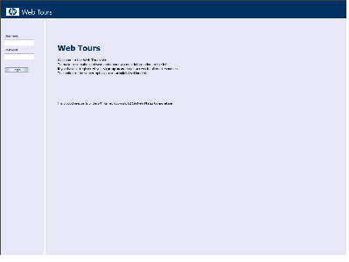

* Navigate to 'http://127.0.0.1:1080/WebTours/index.htm'.

**Step: lr_end_transaction**

**User Operations:**

* End transaction 'Launch'.

**Step: lr_start_transaction**

**User Operations:**

* Start transaction 'login'.

**Step: web_submit_data**

**User Operations:**

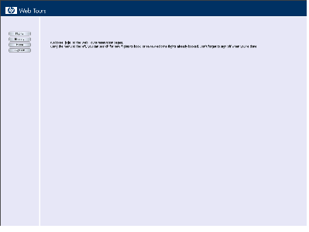

* Submit form to 'http://127.0.0.1:1080/cgi-bin/login.pl'.

**Step: lr_end_transaction**

**User Operations:**

* End transaction 'login'.

**Step: lr_start_transaction**

**User Operations:**

* Start transaction 'Flight booking'.

**Step: web_url**

**User Operations:**

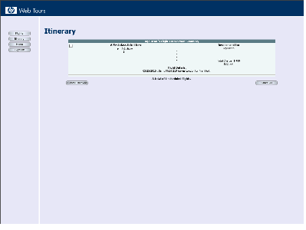

* Navigate to 'http://127.0.0.1:1080/cgi-bin/welcome.pl?page=itinerary'.

**Step: web_url**

**User Operations:**

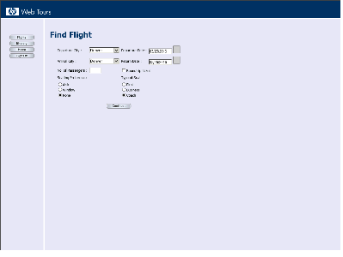

* Navigate to 'http://127.0.0.1:1080/cgi-bin/welcome.pl?page=search'.

**Step: web_submit_data**

**User Operations:**

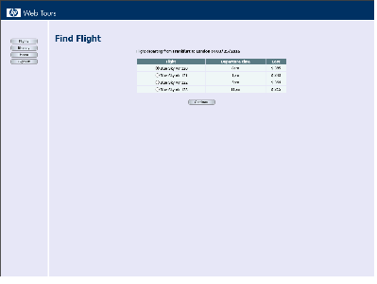

* Submit form to 'http://127.0.0.1:1080/cgi-bin/reservations.pl'.

**Step: web_submit_data**

**User Operations:**

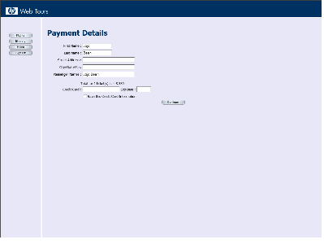

* Submit form to 'http://127.0.0.1:1080/cgi-bin/reservations.pl'.

**Step: web_submit_data**

**User Operations:**

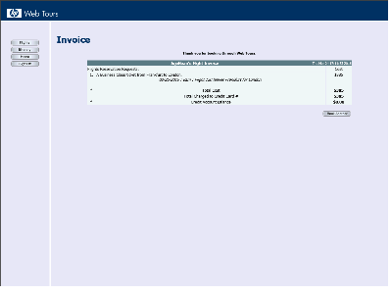

* Submit form to 'http://127.0.0.1:1080/cgi-bin/reservations.pl'.

**Step: lr_end_transaction**

**User Operations:**

* End transaction 'Flight booking'.

**Step: lr_start_transaction**

**User Operations:**

* Start transaction 'Sign off'.

**Step: web_url**

**User Operations:**

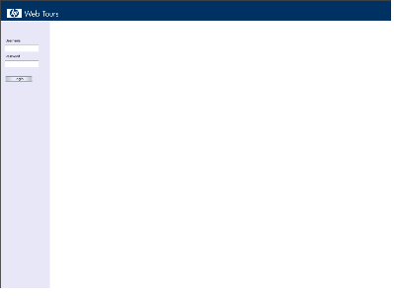

* Navigate to 'http://127.0.0.1:1080/cgi-bin/welcome.pl?signOff=1'.

**Step: lr_end_transaction**

**User Operations:**

* End transaction 'Sign off'.

**Close Application - End of Business Process Description**